1.Create a table listing 5 key cybersecurity terms (such as threat, vulnerability, risk, asset, attack vector) and write a one-line definition for each in your own words.
Cybersecurity Term One-Line Definition
Asset :Anything of value to an organization, including data, software, hardware, or people, that requires protection.
Threat: Any potential danger or event, such as malware or a hacker, that could exploit a system to cause harm or data loss.
Vulnerability: A weakness or flaw in hardware, software, or procedures that can be exploited by a threat.
Risk :The probability or likelihood of a threat exploiting a vulnerability and causing negative consequences.
Attack Vector: The specific path, method, or channel an attacker uses to gain
unauthorised access to a network or system.
2.Research and find a real-world news article from the last 2 years about a major cyberattack on an Indian company or app (for example, a breach involving Zomato, Paytm, or IRCTC). Summarize what happened and identify one threat, one vulnerability, and one risk mentioned in the incident.
1. Tata Electronics Ransomware Attack (June 2026)
- What Happened: A ransomware group known as "World Leaks" successfully breached the systems of tata electonics critical Indian contract manufacturing partner for global tech giants. The attackers published over 200,000 files (totalling 630 GB of data) on the dark web.
- The Impact: The breach exposed highly sensitive, closely guarded global supply chain information. Most notably, it leaked component lists, vendor details, and photos of Apple's upcoming iPhone 18 Pro models. While tata electronics stated that its physical operations remain unaffected, the incident hands counterfeiters and competitors a rare blueprint of Apple's supplier network.
2. KDDI Corporation Data Breach (June 2026)
- What Happened: Major Japanese telecommunications operator KDDI officially disclosed a massive data breach originating from a cyber intrusion into its customer databases.
- The Impact: The incident compromised the personal and account data of up to 14.2 million customers. The exposed information includes names, contact details, phone numbers, and billing metadata. Security teams are currently conducting forensic investigations to pinpoint the initial access vector, and affected users are being warned to watch out for targeted phishing and SIM-swapping attempts.

3.Sign up for a free account on any online cybersecurity dashboard or threat intelligence tool (such as https://www.cybermap.kaspersky.com/ or https://threatmap.checkpoint.com/). Take a screenshot of the dashboard and list 3 types of information or metrics you see displayed.
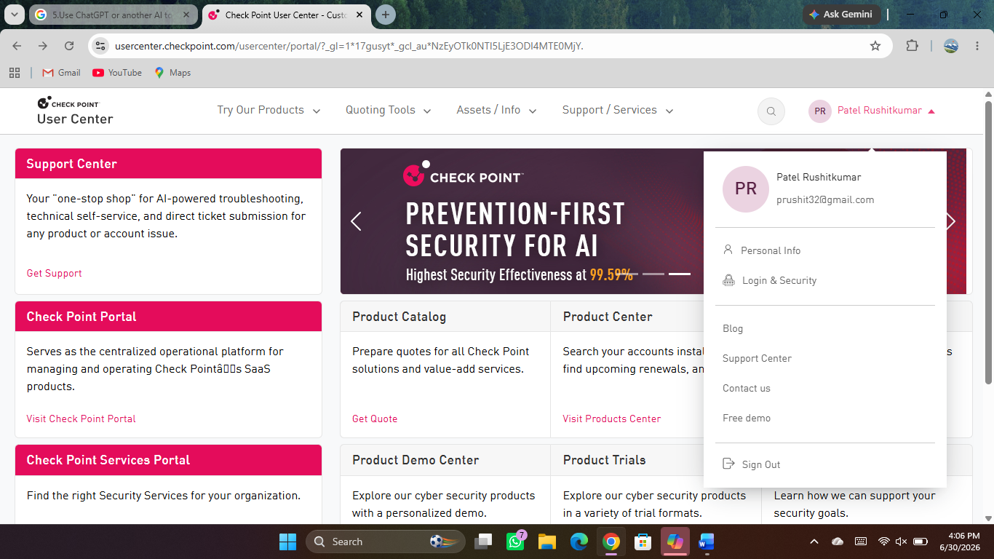

Real-Time Attack Vectors: Visualizes the specific methods hackers are currently using to launch attacks, such as Malicious Files (OAS/ODS), Web Threats (WAV), Vulnerability Scans (IDS), or Phishing/Spam campaigns.
Top Targeted Countries: A ranking system that tracks which nations are receiving the highest volume of concurrent cyberattacks at any given second.
Historical Infection Metrics: Graphs and statistical counters showing total detection counts, daily averages, and a breakdown of the most active malware families over the last 24 to 48 hours.
4.Write a simple phishing email template targeting users of a popular app (for example, 'Your Paytm account is suspended, click here to verify'). Highlight the suspicious elements that make it a phishing attempt. <br><br><em><strong>Hint:</strong> Think about fake links, urgent language, or requests for sensitive info. </em>
Subject: [URGENT] Your Paytm Wallet is Suspended - Action Required Within 24 Hours!
From: Paytm Security Alerts <paytm-support-verification-team@secure-update-alert.net>
Dear Valued Customer,
We detected unusual login activity on your Paytm account from an unrecognized device in a different city. For your safety, your account and digital wallet access have been temporarily suspended.
To restore your account features and avoid permanent deactivation, you must verify your identity immediately.
Please click the link below to log in and confirm your details:
[Click Here to Verify Your Paytm Account Now] (Link points to: http://kyc-verification-portal.com)
Failure to verify your account within 24 hours will result in a permanent block, and any remaining balance will be frozen.
Thank you,
The Paytm Security & Compliance Team
Suspicious Elements Broken Down
Deceptive Sender Address: The email domain secure-update-alert.net does not belong to Paytm. Legitimate emails will come from official domains like @paytm.com.
Urgent and Threatening Language: Phrases like “Action Required Within 24 Hours!” and “permanent deactivation” create panic. Attackers use fear to force users into making rushed decisions.
Generic Greeting: Using “Dear Valued Customer” instead of your actual name suggests a mass-distributed generic campaign.
Suspicious Hyperlinks: The link points to kyc-verification-portal.com rather than the official Paytm application or portal.
Insecure Protocol: The destination URL uses http:// instead of the secure, encrypted https:// protocol.
Request for Sensitive Data: Legitimate financial companies rarely demand immediate credential verification via a random emailed link due to suspicious activity. They will usually ask you to open their official app or website independently.

5.Use ChatGPT or another AI tool to generate a simulated phishing email for a fictional food delivery app (like 'Foodie Pal'). Copy the AI-generated email and explain which parts are likely to trick users and why.
Simulated Phishing Email
Subject: Action Required: Unauthorized login detected on your Foodie Pal account
From: Foodie Pal Support security-alerts@foodiepal-login-verify.com
To: [User Email]
Dear Foodie Pal Customer,
We detected an unusual login attempt to your Foodie Pal account from a new device located in Moscow, Russia, today at 3:14 AM.
As a security precaution, we have temporarily restricted your account access and paused your active Foodie Pal Loyalty Points rewards.
If this was not you, please verify your identity immediately to secure your account and reinstate your profile. Failure to verify within 24 hours will result in permanent account suspension and loss of your saved payment methods.
Secure Your Account & Verify Now
Thank you for helping us keep your account safe.
The Foodie Pal Security Team
Please do not reply directly to this automated email.

Why This Email Tricks Users
Phishing attacks rely heavily on psychological triggers rather than technical flaws. Here is why this specific simulation works:
1. Creates Intense Urgency and Fear
- The Tactic: The email claims an unauthorized login occurred in another country and threatens permanent account suspension within 24 hours.
- Why it works: Fear bypasses critical thinking. When users think their account is actively being hacked, they panic and rush to click the link to stop the threat without checking for red flags.
2. Leverages Financial and Reward FOMO
- The Tactic: It explicitly mentions pausing "Foodie Pal Loyalty Points rewards" and losing "saved payment methods."
- Why it works: Food delivery app users are highly protective of their rewards, credits, and financial data. Threatening the loss of hard-earned points adds immediate tangible value to the scare tactic.
3. Uses a Lookalike Domain (Typosquatting)
- The Tactic: The "From" address uses security-alerts@foodiepal-login-verify.com.
- Why it works: At a quick glance, the word "foodiepal" is visible, which satisfies a casual inspection. Many users do not check the full domain suffix (-login-verify.com) and assume it is an official corporate security address.
4. Mimics Legitimate Security Alerts
- The Tactic: The formatting, automated sign-off, and "Do not reply" footer mimic standard security emails sent by real companies like Netflix, Google, or Uber.
- Why it works: Users are conditioned to see these types of alerts. Familiarity breeds trust, making the email look routine and authentic.

